May 27th 2024,

AWS Cloud Club PICT

Shriniwas Prachand,

We are pleased to inform you that you have been selected as the Event Management Team Member at the AWS Cloud Club PICT for a tenure of one year beginning from May 27th 2024.

As a member of the AWS Cloud Club, you will have the opportunity to collaborate with fellow team members, engage in various cloud computing projects, conduct workshops, hackathons, and other activities aimed at enhancing your skills and knowledge in AWS technologies.

You have the authority to make decisions and contribute to the club under the supervision of the Teacher Coordinator, Mrs. Rachna Karnavat. We believe your enthusiasm and expertise will be a valuable addition to our club.

Excited to have you on board and looking forward to your active participation!

Sincerely,

*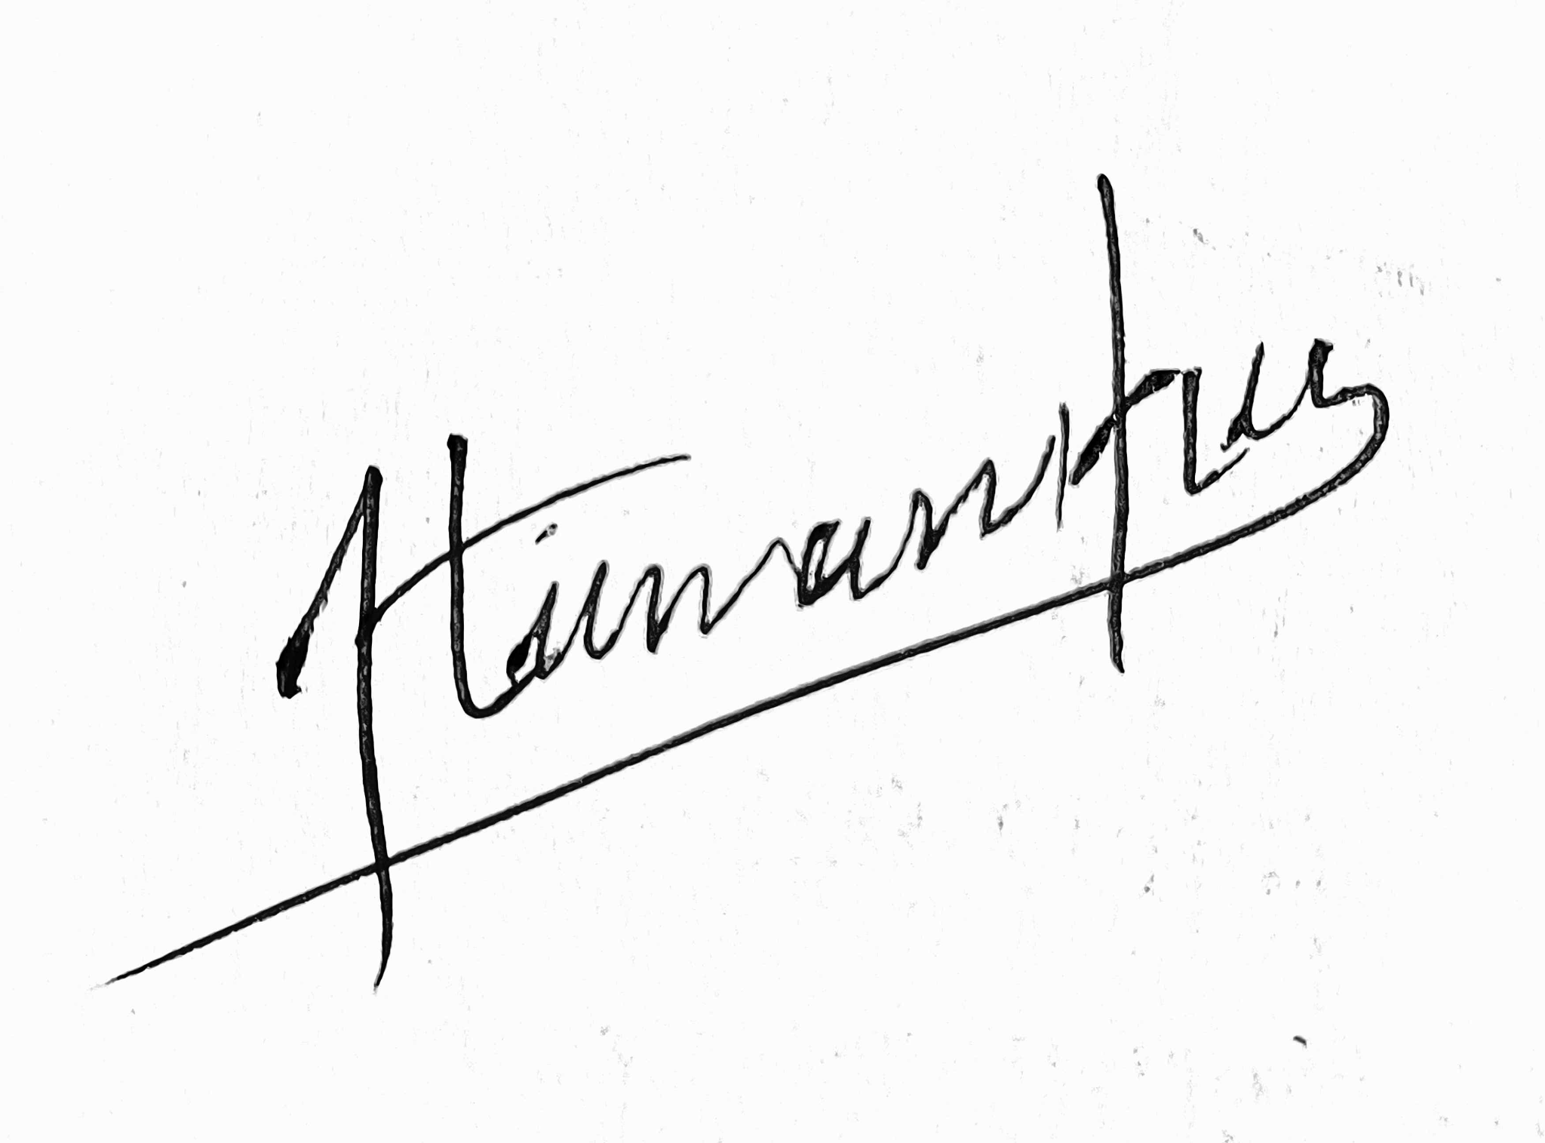 *

Himanshu Sangshetti Mrs. Rachna Karnavat

President Teacher Coordinator

AWS Cloud Club PICT AWS Cloud Club PICT